Section 1: Case Summary

Scenario Title:
Keywords: | Acute pulmonary edema
Brief Description of Case: | A patient is seen by the emergency team, diagnosed with a hip fracture after he slipped and fell, and admitted by the orthopedics service. His medications have been held and he has been made NPO and started on maintenance fluids in anticipation of an operation tomorrow. He is boarding in the emergency department when he wakes up with shortness of breath and hypoxia secondary pulmonary edema. The pulmonary edema is secondary to 1) holding his medications and 2) maintenance fluids.

Goals and Objectives
Educational Goal: | Review the initial assessment and management of a patient with shortness of breath.
Objectives:  (Medical and CRM) | - Assess and manage a patient with pulmonary edema  - Communicate the patient’s assessment to an attending physician via phone
EPAs Assessed: | 1.1 - Recognizing the unstable/critically ill patient, mobilizing the healthcare team and supervisor, and initiating basic life support

Learners, Setting and Personnel
Target Learners: | Medical Students | X Junior Residents | Senior Residents
 | Staff Physicians | Inter-professional | Other
Location: | X Sim Lab | In Situ | Other
Recommended Number of Facilitators: | Instructors: 1
 | Confederates: 1
 | Sim Techs: 1

Scenario Development
Date of Development: | 2015
Scenario Developer(s): | Tim Chaplin
Affiliations/Institutions(s): | Queen’s University
Contact E-mail: | brent.thoma@usask.ca
Last Revision Date: | July 2019
Revised By: | Brent Thoma
Version Number: | 2.0

Section 2A: Initial Patient Information

- Patient Chart
Patient Name: Charles Watson |  |  | Age: 68 |  |  | Gender: Male |  | Weight: 90kg
Presenting complaint: Initially a hip fracture. Shortness of breath
Temp: 36.5 | HR: 105 | BP: 180/100 |  |  | RR: 24 |  | O₂Sat: 83% |  | FiO₂: RA
Triage note: Slipped and fell. Right leg shortened / externally rotated with pain to hip. No LOC.
Allergies: None
Past Medical History:  MI in 2011 (stent to LAD)  CHF (EF 30% on an ECHO from 2012)  Active smoker (no formal diagnosis of COPD) |  |  |  | Outpatient Medications (all held since arrival to hospital):  Lipitor 20mg po od  Coversyl 4mg po od  Furosemide 20mg po od  ASA 81mg po od  Arthrotec 50mg po tid  Bisoprolol 5mg po od  Inpatient Medications:  Received Ringer’s Lactate at 150mL/hour since admission last night  Dilaudid 0.5-1mg IV prn for pain  Acetaminophen 975mg po tid

Section 2B: Extra Patient Information

A. Further History
Include any relevant history not included in triage note above. What information will only be given to learners if they ask? Who will provide this information (mannequin’s voice, confederate, SP, etc.)?

The patient presented yesterday and was admitted by the orthopedics team for right hip fracture. He boarded in an unmonitored area of the ED overnight. The night nurse had no concerns but when his vitals were repeated this morning, he was found to be tachypneic and hypoxic.
B. Physical Exam
A: Speaking clearly with no signs of obstruction.
B: Diffuse crackles on auscultation. Increased work of breathing. Breaks up sentences due to SOB.
C: Normal heart sounds and peripheral pulses. JVP is high and prominent.
D: GCS 15
E: Slightly diaphoretic. Bilateral 2-3+ edema to his legs.

Section 3: Technical Requirements/Room Vision

A. Patient
X Adult Mannequin (specify type and whether infant/child/adult)
Standardized Patient
Task Trainer
Hybrid
B. Special Equipment Required
The equipment that would be stocked in a standard emergency department including monitors, a thermometer, a glucometer, and various oxygen delivery devices (NP, mask, nonrebreather).
C. Required Medications
Nitroglycerin (IV, patch, and spray)
Salbutamol nebulizer / MDI
Furosemide IV / PO

D. Moulage
The patient is slightly diaphoretic and lying flat on the bed.

E. Monitors at Case Onset
Patient on monitor with vitals displayed
X Patient not yet on monitor
F. Patient Reactions and Exam
Include any relevant physical exam findings that require mannequin programming or cues from patient
(e.g. – abnormal breath sounds, moaning when RUQ palpated, etc.) May be helpful to frame in ABCDE format.

The patient should have crackles to bilateral mid lungs, an elevated RR, increased work of breathing, and edema to his legs bilaterally. He will respond normally but break up his sentences due to shortness of breath. He does not have chest pain but will indicate that he finds it hard to breathe. They will feel slightly better if they are moved from a supine to seated position.

Section 4: Confederates and Standardized Patients

Confederate and Standardized Patient Roles and Scripts
Role | Description of role, expected behavior, and key moments to intervene/prompt learners. Include any script required (including conveying patient information if patient is unable)
Nurse | The emergency department day nurse should ask the trainee to see the patient at the beginning of the case. The nurse will provide some basic background information and indicate that they called because the patient seems to have become short of breath. They will not know the patient well as they just started their shift and indicate that no concerns were raised by the night nurse.

Section 5: Scenario Progression

Scenario States, Modifiers and Triggers
Patient State/Vitals | Patient Status | Learner Actions, Modifiers & Triggers to Move to Next State |  | Facilitator Notes
1. Baseline State  Rhythm: sinus  HR: 105  BP: 180/100  RR: 24  O₂SAT: 83% on RA  T: 36.5ºC  GCS: 15 | Is the patient alert? In distress? Seizing? What symptoms do they currently have?  The patient has increased work of breathing and feels SOB. | Expected Learner Actions  Attach monitors  Provide supplemental oxygen  Adjust the bed to a seated position  History and physical exam  Initiate investigations (IV access, Lab, ECG, x-ray) | Modifiers  Changes to patient condition based on learner action  -If seated the patient feels better  -If salbutamol is provided thinks that it might be helping  Triggers  For progression to next state  -Provide supplemental oxygen AND  -Orders lab/ECG/CXR | If the trainee does not provide supplemental oxygen or order lab/ECG/CXR by 3 minutes into the case they should be prompted to do so by the nurse confederate.
2. Oxygen provided  Rhythm: sinus  HR: 105  BP: 160/100  RR: 24  O₂SAT: 87% on NP, 89% on NRB, 95% on BiPap  T: 36.5ºC  GCS: 15 | The patient feels significantly better with oxygen but is still breathing at an increased rate. | Expected Learner Actions  Review the ECG  Review the CXR  State the most likely diagnosis  Discussion with attending  Treatment with nitroglycerine  Treatment with BiPap  Treatment with furosemide (after other management initiated) | Modifiers  -If the learner does not provide the patient with a diagnosis and treatment plan they will become increasingly anxious.  Triggers  -Treatment with nitroglycerine and BiPap is initiated | The trainee should be provided with the ECG and CXR.  If they do not state the most likely diagnosis by 5 minutes into the case they should be asked what they think is going on.  If they do not call their attending or initiate treatment with nitroglycerine / BiPap by 6 minutes into the case they should be prompted to do so.
3. Diagnosis and treatment | The patient is reassured by the treatment plan and begins to feel better. | Expected Learner Actions  Discussion with attending (if not already done)  Consultation of internal medicine for further assessment and management of SOB | Modifiers  -N/A  Triggers  -Case ends when internal medicine is consulted | The attending should provide further prompts if appropriate treatment has not been initiated

Appendix A: Laboratory Results

CBC  WBC  Hgb  Plt  Lytes  Na  K  Cl  HCO₃  AG  Urea  Cr  Glucose  Extended Lytes  Ca  Mg  PO₄  Albumin  TSH  VBG  pH  pCO₂  pO₂  HCO₃  Lactate | Cardiac/Coags  Trop  D-dimer  INR  aPTT  Biliary  AST  ALT  GGT  ALP  Bili  Lipase  Tox  EtOH  ASA  Tylenol  Dig level  Osmols  Other  B-HCG

Appendix B: ECGs, X-rays, Ultrasounds and Pictures

Paste in any auxiliary files required for running the session. Don’t forget to include their source so you can find them later!
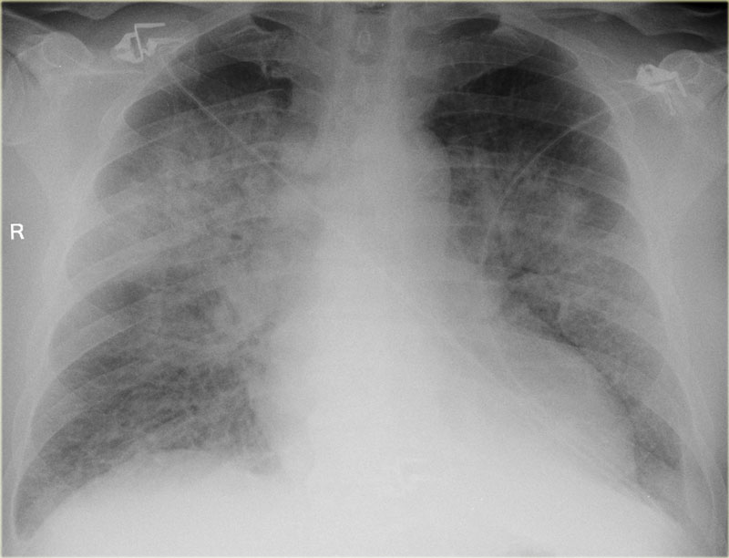
CXR with findings of pulmonary edema. (https://radiologyassistant.nl/chest/chest-x-ray-heart-failure)

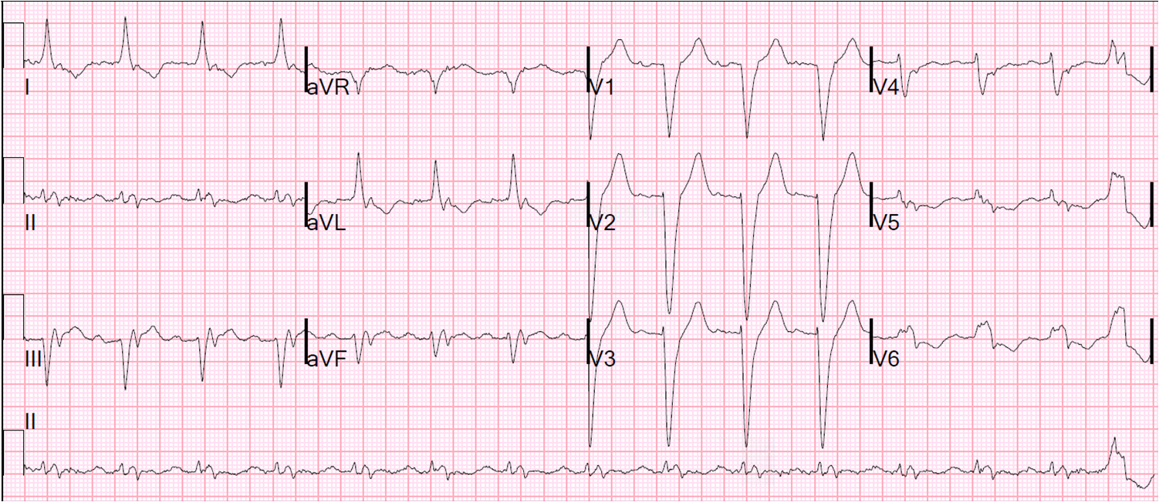
ECG with LBBB. (http://hqmeded-ecg.blogspot.com/2012/10/hyperkalemia-in-setting-of-left-bundle.html)

Ultrasound with B-Lines (https://www.youtube.com/watch?v=uqzWrJeXStk)

Appendix C: Facilitator Cheat Sheet & Debriefing Tips

Include key errors to watch for and common challenges with the case. List issue expected to be part of the debriefing discussion. Supplemental information regarding any relevant pathophysiology, guidelines, or management information that may be reviewed during debriefing should be provided for facilitators to have as a reference.

The challenge for the trainee in this case are the identification of the cause of shortness of breath and its appropriate treatment. As this case is targeted at junior residents, extra attention should be paid to their interactions with the nurse and their attending.

Diagnosis: An appropriate differential will include cardiac ischemia (the ECG with LBBB may be mistaken for ischemia), pulmonary embolism (orthopedic injury and recent immobilization), and COPD exacerbation (history of smoking) in addition to pulmonary edema. The trainees should come to the correct diagnosis based upon the physical exam findings (leg swelling, crackles on auscultation, and B lines in U/S) as well as the history (medications including Furosemide held overnight, IVF given all night).

Management: While it is likely that immediate treatment with oxygen will be provided quickly, the trainee may not provide appropriately aggressive treatment for CHF. While furosemide is an appropriate treatment, it should be stressed that it takes some time to work. More acute treatments include nitroglycerine (spray would be reasonable initially with transition to a patch with improvement or an infusion if the patient does not respond) and BiPap.

Communication: Ideally, the trainees will communicate their orders specifically and directly to the nurse (e.g. “[Nurse name], please put nasal prongs on the patient and start the oxygen at 5L/min” as opposed to “Could we put on some oxygen”). Watch for the use of order lists that are overwhelming (e.g. “Could we get the patient on oxygen, lab to draw a CBC, lytes-6, troponin, a CXR, and an ECG.”). The use of orienting labels (e.g. “This patient is in respiratory distress” or “My working diagnosis is CHF”), explicit summaries (e.g. “Let’s summarize: this is a 68 year old male with a history of CHF and smoking who came in with a hip fracture and became short of breath overnight. On history… Our exam found… Our plan/priorities are…”), and ideas from the team (e.g. “Am I missing anything?” or “Does anyone else have any suggestions?”) should be encouraged. The call to the attending physician should include an introduction (resident name, service, location), concise description of the patient ideally using a standardized format (e.g. SBAR), and explicit request for advice/assistance.

References

1. https://emcrit.org/emcrit/scape/
2.
3.

